Study of Fluid Flow over Corrugated Open Channels
Sathish Raam Ravichandran^{1,a)}, Mothil Sengottian¹, Dharmaraj Manoharan², Sarath Sekar³, Jaffina Sekar⁴, Ishwariya Ravichandran⁴ and Jegathesan Shanmugam⁴
¹Assistant Professor, Department of Chemical Engineering, Kongu Engineering College, Perundurai, Erode, Tamil Nadu, India
²Assistant Professor, Department of Mechanical Engineering, Kongu Engineering College, Perundurai, Erode, Tamil Nadu, India
³PG Scholar, Department of Chemical Engineering, Kongu Engineering College, Perundurai, Erode, Tamil Nadu, India
⁴UG Scholar, Department of Chemical Engineering, Kongu Engineering College, Perundurai, Erode, Tamil Nadu, India

^{a)}Corresponding Author: sathishravi.m@gmail.com
Abstract. Open channel flow is the fluid flow with a free surface open to the atmosphere as in natural water streams such as streams, rivers, and culverts, etc. This flow behavior of open channel flow is governed by the effects of viscosity and gravity relative to the inertial forces of the flow. In this study, the flow across the corrugated rectangular plate at different parameters such as fluid flow rate, viscosity, and the inclination angle is studied. Particles of different density like fine sand, calcium carbonate, and activated carbon were mixed to enhance eddy flow in the channel, thereby increasing the turbulence, retention time. The fluid was then collected using a V-notch at the end of the open channel and recycled back into the system. The eddy formation in found in the system. The further calculation was calculated manually. The result of flow behavior obtained practically is compared by simulating the flow behavior in computational software.
Keywords: open channel, rectangular corrugated plate, eddy flow, turbulence, and flow behavior.

INTRODUCTION
Film flow is a thin flow over a corrugated plate and it has wide application in aerospace, thermal engineering, chemical engineering, light industry, energy, petroleum, and refrigeration [1]. Applications of this ﬂow range is the most common case in heat and mass transfer in the heat exchangers and ordered packing and in most advanced technological processes such as electrochemical plating, chemical etching, and chemical conversion in liquid–gas catalytic reactions [11] .These applications are related to the interfacial and wall transfer rate which is controlled by disturbing the basic flow field through wall corrugations [2]. Flow of this kind occurs in the heat-transfer equipment, such as falling film evaporators and in condensers [3]. These structures are also found in design of the surface of two-phase heat exchangers, and in the various shape of packing which is used to improve gas-liquid contact in the absorption columns and in the distillation trays [2]. Li et al in 2015 found that the mass transfer efficiency of film flow over an irregular shape is approximately three to five times higher than film flow over a flat one [4].
In this experiment by increasing the flow rate the thickness of the film gets increased. Thickness directly influences the Reynolds number. As the Reynolds number increase eddy also tends increases. In the formation of eddies with the increase in Reynolds number the eddy first decrease and finally it disappears [8]. Bontozoglou and Papapolymerou (1997) was the first one to discover the surface resonance phenomenon of film flow over an inclined corrugated structure. They observed that the surface amplitude increases to the maximum with increasing Reynolds numbers [4]. The flow over corrugations was also studied, and the vortex was found to disappear in a certain area, this phenomenon may be referred as the resonance [9]. The resonance produces the largest free-surface area, which helps to improve the mass transfer efficiency. The Resonance remains sharp but declines in the amplitude [5]. The factors such as feed rate, feed composition, pressure, and the temperature can affect the fluid flow and mass transfer. Any change in this condition would cause a considerable effect on the mass transfer, yet the flow computation involves large computational work and the results might not always be reliable [6]. In this paper, the film flow over rectangular corrugations is studied by numerical simulations- computational fluid dynamics (CFD) and by experiments [10]. In formulating of the k−ɛ model, the idea is to derive the exact equation for ɛ and from it to find suitable approximations for the exact equation governing its behavior [12]. The approach to Validation Assessment is to perform a systematic comparison of CFD simulation results to experimental data [10].
It is inferred from the above listed review that available information on the film flow over a corrugated plate is studied in many aspects. Thus, in the present work we concentrate on the flow across the corrugated rectangular plate at different parameters such as fluid flow rate, viscosity, and the inclination angle is studied. Particles of different density like fine sand, calcium carbonate, and activated carbon were mixed to enhance eddy flow in the channel, thereby increasing the turbulence, retention time. The flow behavior was comparatively studied in CFD- Ansys fluent.

EXPERIMENTAL SETUP AND METHODOLOGY

Method
In this study the complex corrugulation is made less complicated to a 2D geometric plate. The corrugated plate consist of a rectangular corrugation. Rectangular open channel is contructed using glavanised stainless sheets, in which temporary partitions where constructed. The length of corrugulation is 0.1m and height 0.01m. The same setup was used to study a film flow over corrugated metal plates (5 plates)each angle 45°and the third plate is the primary study object. Then the water is collected using a V-notch at the end. The fluid enters the system by adjusting the rotameter. The parameters for the study were changed namely, velocity of fluid, viscosity of fluid, inclination angle, shape of corrugation, etc. The result of flow behaviour obtained practically is also compared by simulating the flow behavior in computational software. The flow involves existence of a free surface between the flowing fluid and the atmospheric air above it. The flow is generally governed by the forces of gravity and inertia. Thus the fluid is allowed to flow over these channels at various flow and compared with rectangular open channels. These plates helps in rapid mixing, increase the turbulence, increase the retention time and also to increase the contact time between the catalyst .

FIGURE 1.Rectangular corrugation
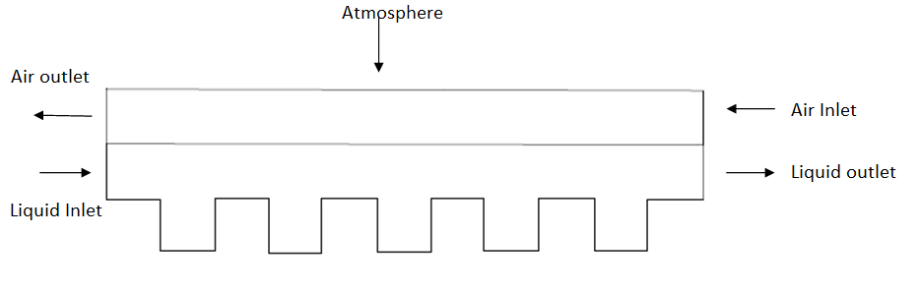
FIGURE 2.Front view of the setup
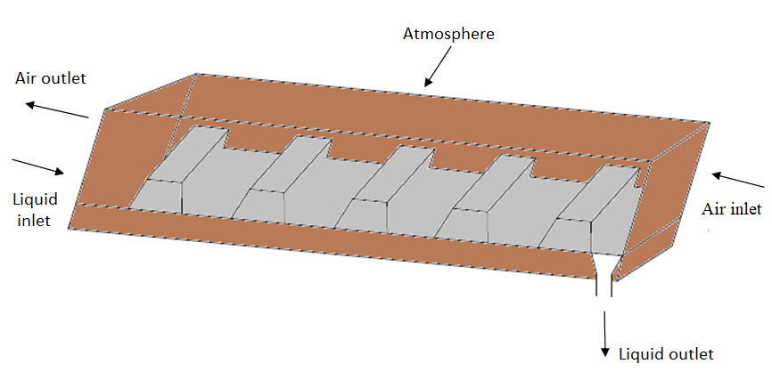
FIGURE 3. Overview of the setup
Reynolds number (Re) is a dimensionless parameter that represents the flow rate and it is defined as
(1)
where µ is the viscosity of the liquid, V is the velocity of the liquid, ρ is the density of the liquid, D_{h} is the hydraulic diameter. The hydraulic diameter is used when handling flow in non-circular tubes and channels. Hydraulic diameter is mainly used for calculations involving turbulent flow. As Reynolds number increases the eddy size also increases and subsequently when the Reynolds number decreases eddy size also decreases.
(2)
where W is the width of the channel and is the thickness of the liquid film.

Flow analysis
Vlachogiannis and Bontonzoglou in 2002 defined the phenomena of film flow resonance. The free surface amplitude reaches maximum at a particular Reynolds number for a specific corrugated structure [13]. For a specific corrugated structure, free surface amplitude reaches the maximum at a particular Reynolds number. The free surface amplitude is the difference between the maximum and minimum free surface in a corrugated period [14].
As the fluid flow over a rectangular plate, with the increase in Reynolds number the film thickness increases gradually. With increase in Reynolds number the hydraulic diameter gradually increases. In the formation of eddies with the increase in Reynolds number the eddy first decrease and finally disappears.

Bottom Eddies and Resonance Section
To study the bottom eddy, a dimensionless number E is defined:
(3)
where B_{a} is the eddy length in horizontal direction, Lo is the length of corrugation. In order to find the values of B_{a} , the K-epsilon model is used.
(4)
where is the K- epsilon factor and the value of is 0.09 and length (L) is the characteristic length; l=0.07D_{h}
(5)
(6)
where U is the velocity magnitude and I is the turbulence intensity. Turbulence intensity is defined as the ratio of standard deviation of fluctuating wind velocity to the mean wind speed; it represents the intensity of wind velocity fluctuation. The turbulence intensity is defined as:
(7)

RESULTS AND DISCUSSION

Thickness Vs Flow rate
As the fluid flow over a rectangular plate, with the increase in flow rate the film thickness increases gradually. In this experiment the flow rate is adjusted by rotameter.

Thickness Vs Reynolds number
The below graph describes the average thickness of the liquid film with different Reynolds number. Thickness of the fluid film increases with increase in Reynolds number.

Reynolds number Vs hydraulic diameter
With increase in Reynolds number the hydraulic diameter gradually increases. Reynolds number is directly proportional to hydraulic diameter. Hydraulic diameter, DH is mainly used for handling flow in non – circular tubes and channels.

Eddy length Vs Reynolds Number
In the formation of eddies with the increase in Reynolds number the eddy first decrease and finally disappears. For Reynolds number 169.5 to 539.78 there is a linear increase in eddy length later for the Reynolds number 727.93 eddy formations occurs, these eddies enhances the mixing and it also creates some disturbance. For Reynolds number 938.9 to 1593.5 again there is a linear increase in eddy length.

Eddy Vs Reynolds number
In plotting the graph between eddy and Reynolds number the resonance is created. The resonance produces large free-surface area. Reynolds number at 727.93 is called as Resonance point. Resonance point is formed when eddy get submerged and then expand. For the rectangular corrugation, the resonance point is independent of the corrugation length [15].
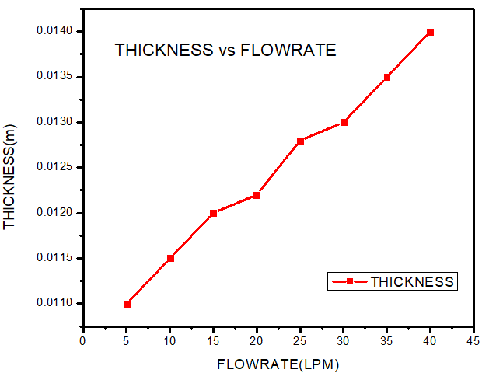 | 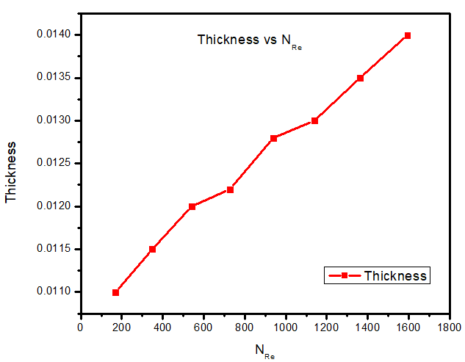
FIGURE 4. Thickness Vs flow rate | FIGURE 5. Thickness vs Reynolds number
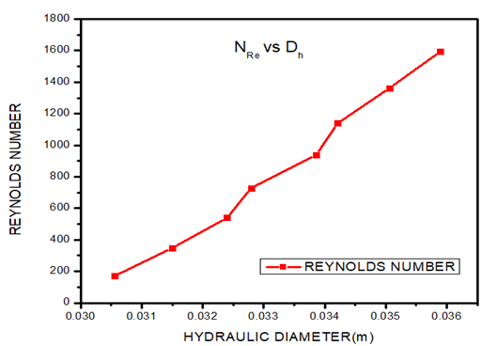 | 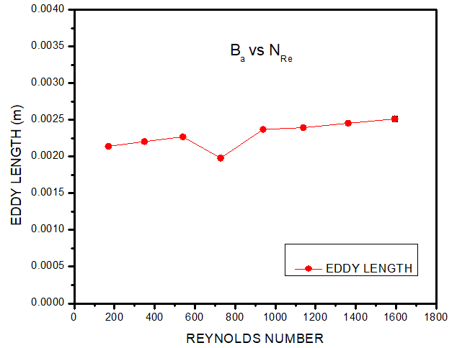
FIGURE. 6 Reynolds number vs hydraulic diameter | FIGURE 7. Eddy length vs Reynolds number

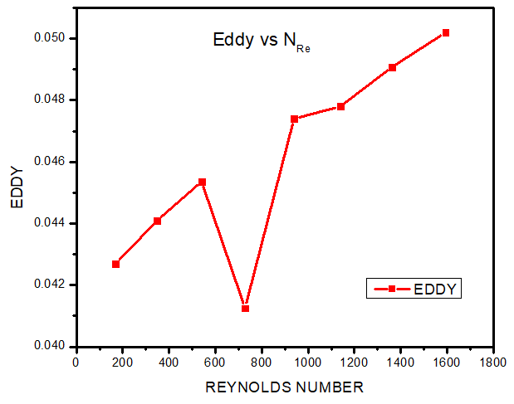
FIGURE 8. Eddy Vs Reynolds Number

ANALYSIS COMPARION WITH CFD
Computation fluid dynamics is use to analyze and solve problems that involve fluid flows. CFD can analyze complex problem involving fluid-fluid, fluid-solid, fluid-gas interaction. Results of simulation allow predicting the stages of film formation during fluid flow, film thickness, and velocity profile of phases [16]. In this study fluid- gas interaction is studied using CFD software. The collection of all elements or cells is called mesh or grid. Each cell of the mesh represents an individual solution when these are combined as a whole network, this result in solution for the entire mesh. In this experiment Grid convergence study is carried out. Thus the meshing process was done.

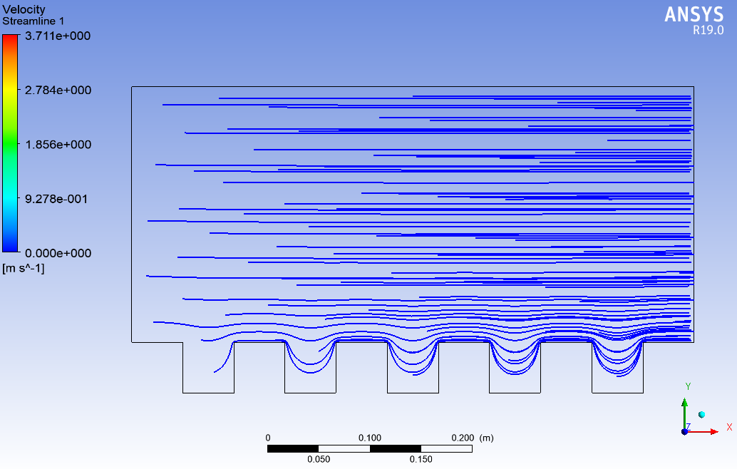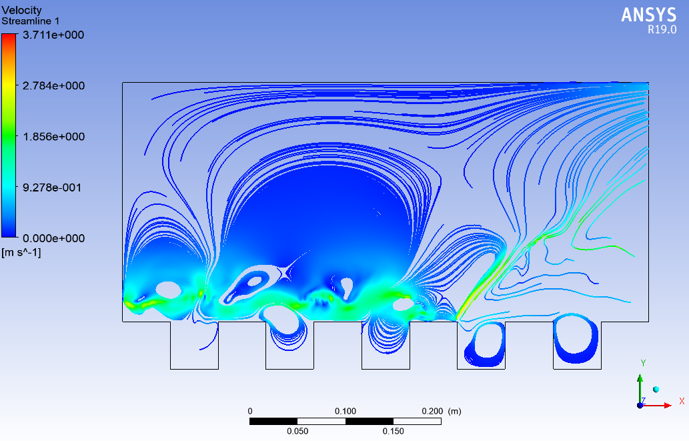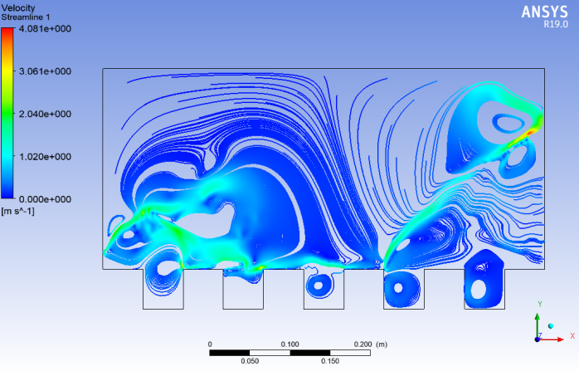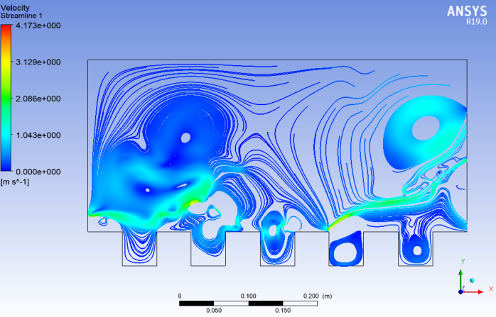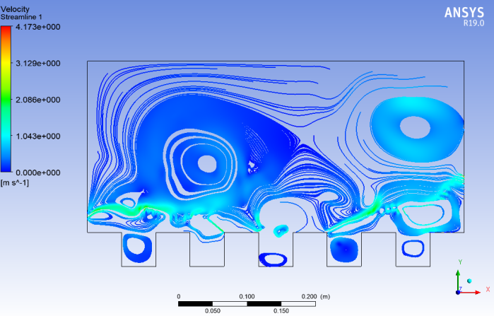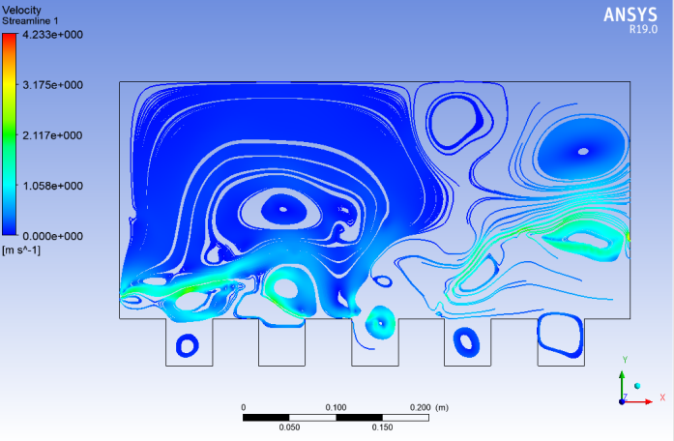
FIGURE 9. Flow field velocity with changing time
- t=0sec ; 2)t=0.2 sec ; 3)t=0.4sec ; 4)t=0.6sec; 5)t=0.8sec; 6)t=1 sec
Boundary layer concept was implemented. For turbulent flow, the boundary layer is defined as a thin region on the surface of a body in which viscous effect is important which is taken into account. Inflation on the wall for CFD was performed. Inflation is related to meshing and it gives more accurate result. Hence we create inflation by selecting the wall boundary and number of layers in ansys fluent. Number of element can be increased to get more accurate result but it will take more time, this is one drawback in increasing the number of element. So we are limiting the no of element to 49,000.

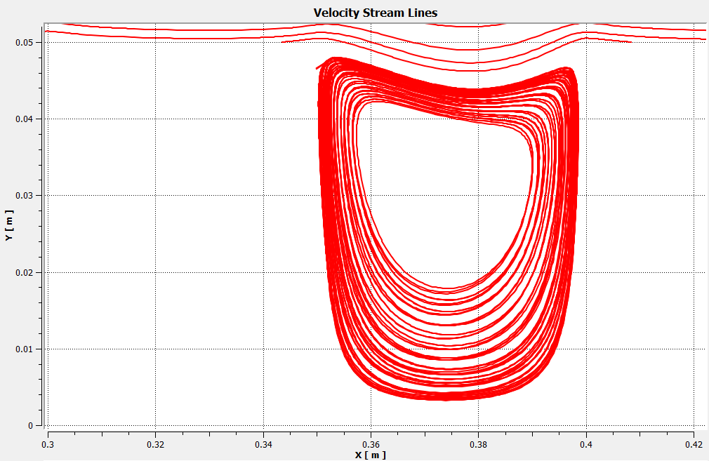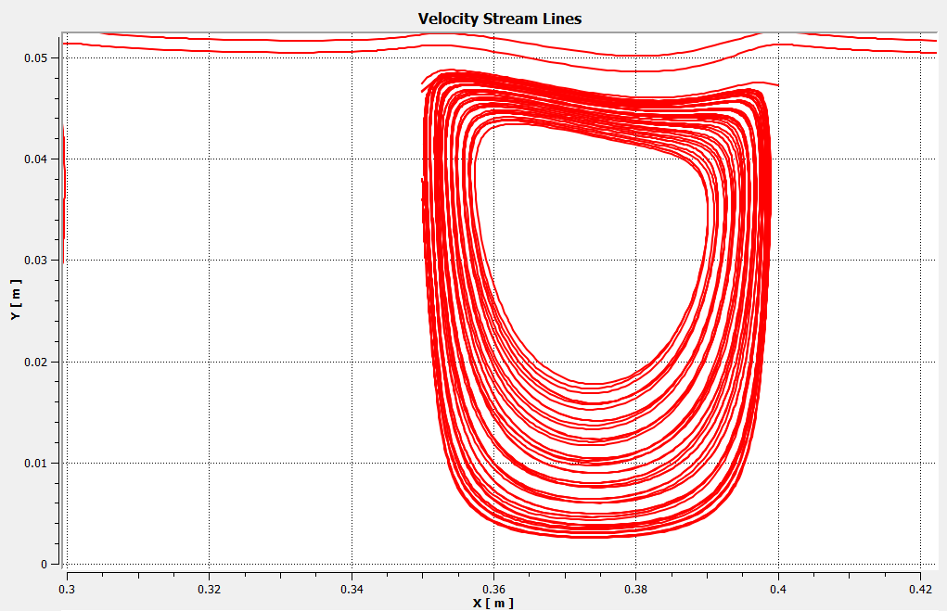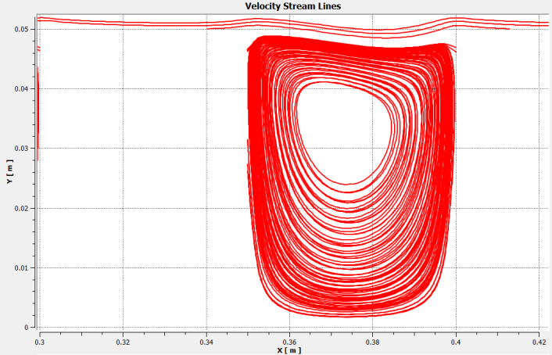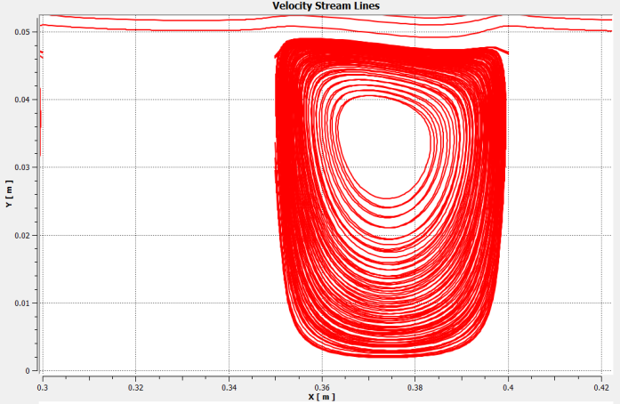
FIGURE .10.Eddy areas (Third plate)
The experimental study explains that with increase in Reynolds number at a particular point resonance is produced. These resonance points are formed when eddy gets submerged and later expand [15]. When comparing the same using computation fluid dynamics (CFD) analysis and while taking only the third plate into account. The reason for taking the third plate is while performing the experiment manually we found that the eddy formation was more and clearly visible in third plate. In CFD analysis with different velocity and time, the eddy formation was compared. In Fig.10 eddy size shows a notable reduction with different velocities. This This implies that the bottom eddies are suppresssed before occurance of resonance phenomena.

CONCLUSIONS
In this study, the flow across the corrugated rectangular plate at different parameters such as fluid flow rate, viscosity, and the inclination angle is studied. Particles of different density like fine sand, calcium carbonate, and activated carbon were mixed to enhance eddy flow in the channel, thereby increasing the turbulence, retention time. The fluid was then collected using a V-notch at the end of the open channel and recycled back into the system. The result of flow behavior obtained practically is compared by simulating the flow behavior in computational software – Ansys Fluent. Simulation and experiments were performed to study the behavior of fluid, eddy formation, and film flow resonance.

REFERENCES
- Ya-qiong Guo, Ning-xin Liu, Lai Cai,Wei-rong Hong”Experimental and numerical investigations of film flow behaviors in resonance section over corrugated plates”Guo et al. / J Zhejiang Univ-Sci A(Appl Phys & Eng), Vol. 2, 2019 20, pp.148-162.
- K. Argyriadi, M. Vlachogiannis, and V. Bontozoglou”Experimental study of inclined film flow along periodic corrugations: The effect of wal steepness” PHYSICS OF FLUIDS, Vol. 18, No. 1, 2006.
- V.Bontozoglou and G.Papapolymerou ”Laminar film flow down a wavy incline”Int. J. Multiphase Flow, Vol. 23,No. 1 , 1997, pp. 69-79.
- Jie Li, Yaqiong Guo, Zhong-yao Tong, Wei-rong Hong,”Comparative Study on the Characteristics of Film Flow with Different Corrugation Plates” Microgravity Science and Technology, Vol. 27, 2015, pp.171-179.
- C. Heining a,*, V. Bontozoglou b, N. Aksel a, A. Wierschem a,c”Nonlinear resonance in viscous films on inclined wavy planes” International Journal of Multiphase Flow, Vol. 35, 2009, pp. 78-90
- Jie Li1·Yaqiong Guo1·Zhong-yao Tong1·Wei-rong Hong1”Comparative Study on the Characteristics of Film Flow with Different Corrugation Plates” Microgravity Science and Technology, Vol. 27, 2015, pp.171-179.
- Yu. Ya. Trifonov a”Viscous liquid film flows over a periodic surface” International Journal of Multiphase Flow , Vol. 24, November 1999, pp. 1139-1161.
- Trifonov YY,2016”Viscous liquid film flow down an inclined Corrugated Surface. Calculation of the flow stability to arbitrary perturbations using an integral method” Journal of Appiled Mechanics and Technical Physics, Vol. 57, 2016, pp. 195-201.
- Aleksandr N. Pavlenko, Oleg A. Volodin, Anton S. Surtaev”Hydrodynamics in falling liquid films on surfaces with complex geometry” Microgravity Science and Technology, Vol. 21, No. 207, 2009.
- Qunsheng Li, Tao Wang, Chengna Dai, Zhigang Lei”Hydrodynamics of novel structured packings: An experimental and multi-scale CFD study” Chemical Engineering Science, Vol. 143, 2016, pp. 23-35.
- N. A. Malamataris1 and V. Bontozoglou”Computer Aided Analysis of Viscous Film Flow along an Inclined Wavy Wall”Department of Mechanical and Industrial Engineering, University of Thessaly, GR-38334 Volos, Greece, Journal of Computational Physics, Vol. 154, 1999, pp. 372-392.
- T.-H. Shih, W.W. Liou, A. Shabbir, Z. Yang, and J. Zhu”A New k-e Eddy Viscosity Model for HighReynolds Number Turbulent Flows-Model Development and Validation”
- M.Vlachogiannis and V.Bontozoglou”Experiments on laminar film flow along a periodic wall ”Department of Mechanical and Industrial Engineering, University of Thessaly, GR-38334 Volos, Greece, Journal of Fluid Mechanics, Vol. 457, 2002, pp. 133-56.
- M. Scholle, A. Wierschem and N. Aksel, Bayreuth, Germany”Creeping films with vortices over strongly undulated bottoms” Acta Mechanica, April 2004.
- Ya-qiong Guo, Wei-rong Hong, Jens-Uwe Repke” Hydrodynamics of New Structured Packings: An experimental and multi-scale CFD study” Chemical Engineering Science , Vol. 143, 2016, pp. 23-35.
- Beata Szulczewska, Ireneusz Zbicinski, Andrzej Gorak”Liquid Flow on Structured packing: CFD Simulation and Experimental study” Chemical Engineering & Technology: Industrial Chemistry-Plant Equipment-Process Engineering-Biotechnology, Vol. 26, No.5, 2003, pp. 580-584.

